Shape matching using a dynamic time warping algorithm

Information Technology (M.Eng.)  Computational Intelligence  Pratik Desai  Matriculation 1438367  pratik.desai@stud.fra-uas.de | Information Technology (M.Eng.)  Computational Intelligence  Poonam Paraskar  Matriculation  Poonam.paraskar@stud.fra-uas.de

Abstract—Shape matching plays a critical role in various applications, ranging from image retrieval to pattern recognition. This paper presents a novel approach for shape matching using the Dynamic Time Warping (DTW) algorithm. DTW is a powerful technique that measures the similarity between two time-series sequences by considering both temporal and amplitude variations. In this work, we leverage the strengths of DTW to address the problem of shape matching in the context of archaeological object analysis.

The proposed method involves transforming images into sequences and then applying DTW to compute the similarity between the shape representations. To ensure robustness and accuracy, the sequences are derived from grayscale images using appropriate normalization techniques. The DTW algorithm is adapted to handle sequences of pixel values, allowing for precise comparison of shapes. A matching threshold is introduced, which is determined based on the average sequence length, to assess the level of similarity between shapes.

Experimental results demonstrate the effectiveness of the proposed approach in identifying objects with similar shapes in archaeological datasets. The DTW-based shape matching yields promising outcomes, showcasing its potential as a valuable tool for shape analysis in archaeology. By harnessing the capability of the DTW algorithm, this study contributes to advancing shape matching techniques and their application to various fields, including archaeological research.

Keywords—Shape Matching, Dynamic Time Warping, Archaeology, Image Analysis, Pattern Recognition.

Introduction
To develop classifiers that map input time series into discrete variables (classes) that define one or more properties of the time series themselves. The Time Series Classification (TSC) task is often solved by supervised algorithms.
Standard classification techniques, such as those used on tabular data, cannot be employed directly since they treat each sample separately from the rest.
We cannot consider each sample of a time series independently of the other samples because time series data must be considered in the context of their temporal ordering.
Distance-based approach is famous for such technique to implement –
It is a non-parametric method for determining class membership that combines distance measurements and a classifier. A k-nearest neighbor (KNN) algorithm is typically used in the classifier to determine whether the time series you wish to label is like any in the training dataset. The time series under study relates to the nearest class, or an accumulation of the nearby classes, based on the neighborhood. DTW, or Dynamic Time Warping, is an illustration of a distance-based strategy.
Distance Matrix - In order to classify time series, it is necessary to compute the distance between two series while considering their temporal relationships and sample dependence. The right metric selection is essential to this strategy. (Dynamic Time Warping for Time Series Classification | Eni digiTALKS (medium.com) )
In several fields, the Dynamic Time Warping algorithm (DTW) is a well-known algorithm. Although it was first developed in the 1960s [1] and widely researched in the 1970s by using it for voice recognition [2], [3], it is today utilized in a variety of fields, including handwriting and online signature matching [4], [5], [6], and [7] identification of gestures and sign language. [6], time series clustering (time series databases search) [8], and data mining [9] [10] [11] [12] [13] this work seeks to aid in the understanding of software metrics.
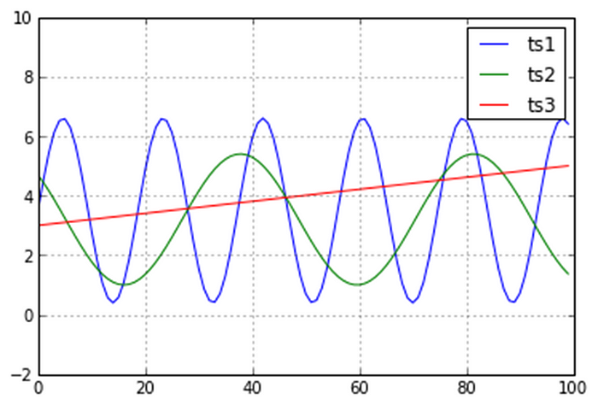
Euclidean Distance- This algorithm is very famous but Euclidean distance is inappropriate in light of Time Series Classification because, despite maintaining the temporal order, it estimates the distance in a pointwise fashion. In fact, amplitude is considered when computing the similarity using Euclidean distance of two time series, regardless of phase shift, time shifting, or distortion.

Figure 4 - examples of time series to compare

This phenomenon is happening because the Euclidean Distance is comparing the amplitudes of the curves, without allowing any time stretch.
Take Figure 4 as an example. Three time series are available: ts1, ts2, and ts3. Even though the two sinusoidal curves' phase and frequency differ somewhat from one another, we want to be able to tell that they are comparable to one another since they have the same form and upward and downward trend. However, the straight-line ts3 findings come closer to ts1 if we compute the Euclidean metrics.
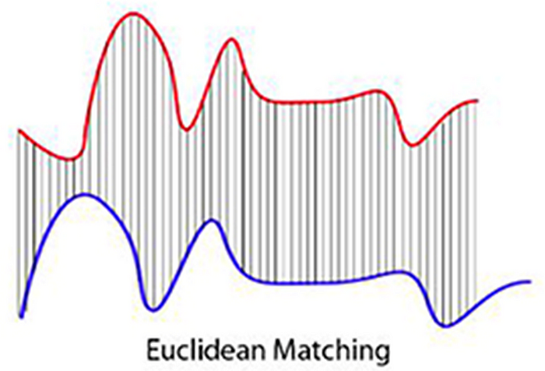

Figure 5 — Euclidean Matching

The Dynamic Time Warping has been introduced to avoid the problem of the Euclidean Distance.
The implementation of pothole detection using the Dynamic Time Warping (DTW) algorithm represents a significant leap in road safety technology. By harnessing the power of DTW, this innovative system not only learns and adapts to a reference image but also seamlessly converts all input images to grayscale, allowing for a standardized and robust analysis process.
What sets this solution apart is its ability to compute a minimum distance matrix, enabling it to efficiently and accurately identify images that closely match the reference image. This precise image matching capability is a game-changer in identifying potential threats and hazards on the road, thus significantly enhancing road safety.
In this project we have also demonstrated the basic and actual working of DTW algorithm in one of the scripts. We have also considered one more use case of speech detection using DTW algorithm. For speech detection we use feature of KNN classifier for prediction, KNN classifier is trained with voice samples, and it predict the sample which has been provided for testing, based the trained representation in the Distance matrix.

METHODOLOGY
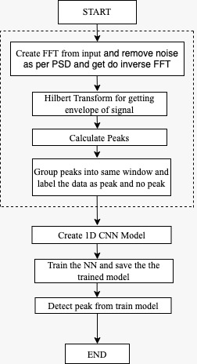
The experiment of automated robust first peak detection in a time signal by CNN has been conducted following the flowchart diagram (Figure 1). For the sake of simplicity, the experiment is divided into parts. The process of experiment begins with calculating FFT which converts time domain signal to frequency domain signal, the results are obtained by suitable modification of the Fourier transform coefficients and take complex conjugate to eliminate imaginary value. Secondly, we use this case to filter noisy data by finding which peaks are above the noise floor and remove everything below that floor, and then IFFT to de noise the signal. Here, we filter and take all the values that have F magnitude squared less than 1.5, than take the power spectrum multiplied by indices vector which zero out all the indices that have small Fourier coefficient and keep only those that have power greater than 1.5. The signal is then filtered by inverse Fourier transform. Then, Hilbert transform is used to extract complex components from a signal. HT generate the envelope of the time signal by calculating the magnitude of the time function. Calculate the peaks and Save the real values of peaks to group the peaks into the same window. Then create an 1D CNN network model and feed the input into CNN model with supervised learning technique. The training process using CNN model requires the CNN model to adjust weigh according to training and validated data. Lastly, the trained CNN model is used for peak detection.

Preprocessing
Preprocessing is a method to pre-process on data. All input variables are normalized, de correlated and then transformed to a neural network. Preprocessing composes of

First Fourier Transform:
Preprocessing performs FFT on time signal data. Fourier transform is one of the most widely used techniques in applied mathematics and engineering from filter design to signal processing. In brief, Fourier transform is based on where functions of suitable properties can be represented with a linear combinations of trigonometric functions. This Trigonometric Functions can be seen as extracting frequency-domain information from a time-domain signal, used for alternative or more efficient ways of investigating or modifying a signal [4]. The Fast Fourier transform (FFT) algorithm was given by

Figure 1: Flowchart Diagram of the Experiment
James Cooley and John Tukey in 1965 which has enabled a wide range of numerical applications. These applications include data compression, handling noisy signals, analysis of crystal
Structures, and solving partial differential equations [5]. The DFT equation X(k) = ∑x(n)W_{N}^{nk} is decomposed into several short transforms and recombined in the FFT formula. In FFT the input signal is converted into frequency domain using DFT and multiplied by the frequency response of the filter, and then converted back into time domain using inverse DFT. Fourier transform (FFT) and inverse fast Fourier transform (IFFT) eases the computational complexity of the DFT from O(N2) to O (N log N). Here, given a sinusoidal signal which is in time domain, when applied Fourier transform it provides the constituent signal frequencies. Fourier transforms are used for both periodic and non-periodic signals where they can be transformed from time domain to frequency domain.

Hilbert Transform
Hilbert Transform has played a vital role in signal domain, and it has many applications in different fields. HT provides a ±90° Phase shift to the input signal, therefore if the input signal chooses to be a sine function the output will give cosine function. In Fourier transformation one can change the time domain to frequency domain, but in Hilbert Transform the operation remains the same in its time or frequency domain [6]. HT is an alternative method to extract complex components from a signal. The Hilbert Transform characterized by,

h(t)=
HT rotates the Fourier components in complex space by the formula dt. The scientific computing software MATLAB has a Hilbert () function that “computes the so-called discrete-time analytic signal X = Xr + i*Xi such that Xi is the Hilbert transform of Xr” [7]. In MATLAB’s implementation of the Hilbert () function it takes advantage of the fast Fourier transform (FFT).

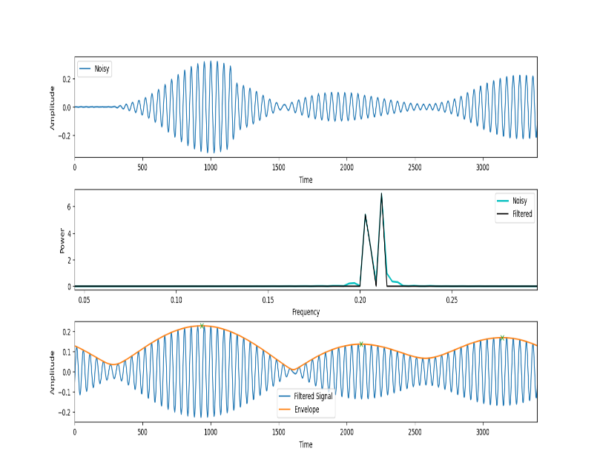
Figure 3: Upper enveloping by Hilbert Transform
The Hilbert () function does the calculation in three steps: First do the FFT of Xr. Then set the elements in FFT which correspond to frequency −π < ω <0 to zero. Finally do the inverse FFT. A
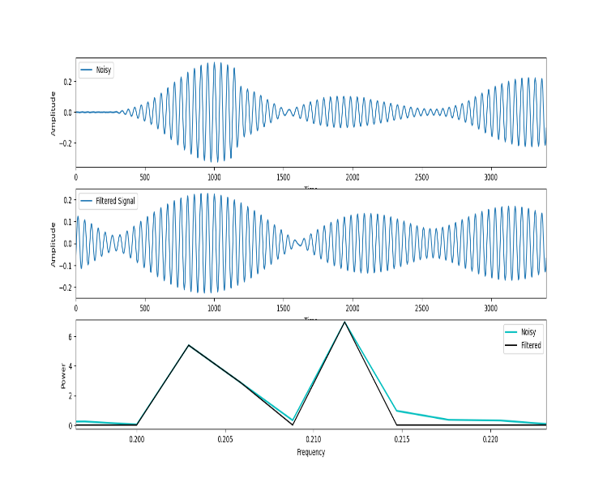
Figure 2: Filtering signal using FFT
Hilbert transformer is useful for envelope extraction shows in figure 3. This can be understood by the formula that Hilbert transform produces a sin(ωt) for every cos(ωt). HT can generate the envelope of the time signal by calculating the magnitude of the time function. Envelope analysis is the slow overall change and sound intensity over time. Hilbert transform 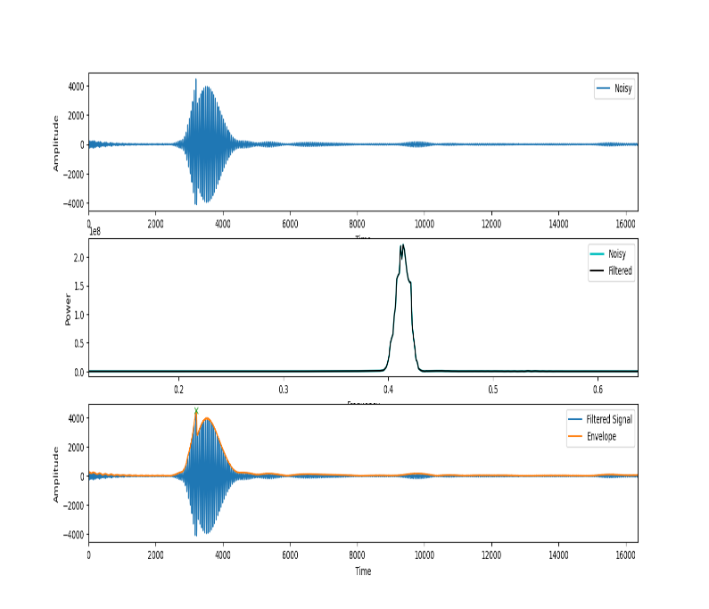
Figure 4: Performing FFT and Hilbert Transform
can be used to find an imaginary function to a real valued signal, as the real signal can be analytically extended from the real axis to the upper half of the complex plane. (Figure 4) shows the final result.

Training and Testing
In the preprocessing stage, FFT is used for noise removal. Then, the signals are fed to the CNN method for peak detection. In the experiment, the supervised learning has been used to train the 1D CNN model. We train the neural network with the peak from preprocessing. The CNN model then detects the peak from trained model. There are numerous available conventional CNN models. We chose one of the models listed on the Keras website and made a small adjustment to it to meet the issue. A 1D CNN has generally raw data as input instead of handcrafted features. Input data is processed through different trainable convolutional layers for learning an appropriate representation of the input data. Accordingly, local connectivity theorem, the neurons in a layer are connected only to a small region of the previous layer which is called a receptive field. The input of a 1D CNN is an array representation of the audio waveform, which is denoted as X. Set of parameters Θ is used to map the input to the prediction by the equation,

T = F (X | Θ) = fL(...f2(f1(X | Θ1) | Θ2) | ΘL)….(1)
Where L is the hidden layers number in the network. For the convolutional layers, the operation of the layer 1 can be expressed as:
Tl = fl(Xl | Θl) = h(W ⊗ Xl + b), Θl = [W, b]……(2)
where ⊗ is the convolution operation, Xl is two-dimensional input matrix in N fields, W is a set of one dimensional kernels used for extracting a new set of features from the input array, b defines bias vector, and h() is activation function. The shapes of Xl, W and Tl are denoted as (N, d), (N, m) and (N, d − m + 1) respectively. For increasing the area covered by the next receptive fields, several pooling layers are applied between the convolutional layers. The output of the final convolutional layer is then used as input of several fully connected layers, which can be described as:
Tl = fl(Xl | Θl) = h(W Xl + b), Θl = [W, b]……….(3)

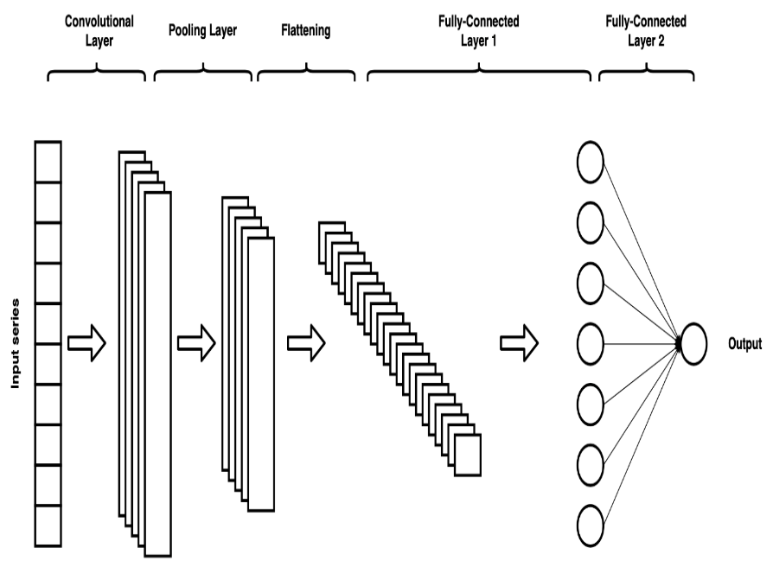

Figure 5: Simplified schema of 1D CNN
The 1D CNN can aggregate the local features and cut down the dimensions of data through convolutional learning and spatial pooling operations.
Here, the convolutional layers read the input of 1D time series and drag a kernel over the time series. The kernel defines the features we want to locate in the series and it has the same width as the time series, so it can only move in one direction. For each step, the input is multiplied by the values of the kernel. Then a non-linear activation function is applied to the result. This way, the original input series is transformed into an interpretation of the input called the filter map. The next step is to apply a pooling layer, which reduces the size of the series, but-at the same time-preserves the identified characteristics. Convolutional and pooling layers can be stacked on top of each other to provide multiple layers. The results of the pooling layer can be passed to a fully connected layer.
First 1D CNN layer: Specifying a filter in the top layer (or also called feature detector also called kernel size). In order for the neural network to learn a single feature in the first layer, only one filter would need to be defined. The output matrix contains the weights for a single filter in each column.

Second 1D CNN layer: The second CNN layer will be fed the output of the first CNN. Using the same reasoning as the top layer

Max pooling layer: After a CNN layer, a pooling layer is frequently employed to simplify the output and avoid overfitting the data.

Third and fourth 1D CNN layer: In order to learn higher level features, a further set of 1D CNN layers is used.

Average pooling layer: A further pooling layer averaged out will help prevent overfitting. This time, the average value of two weights within the neural network is used rather than the maximum value. In the neural network on this layer, there is only one weight left for each feature detector.

Dropout layer: The neurons in the network will get 0 weights at random in the dropout layer. Given that we selected a rate of 0.5, 50% of the neurons will have their weight set to 0. By

Figure 6: CNN Layer working Procedure

performing this function, the network's sensitivity to slight fluctuations in the data is reduced. As a result, it ought to further improve our data accuracy.

Fully connected layer: The height vector will be decreased in the last layer. Another matrix multiplication is used to perform this reduction.

Evaluation
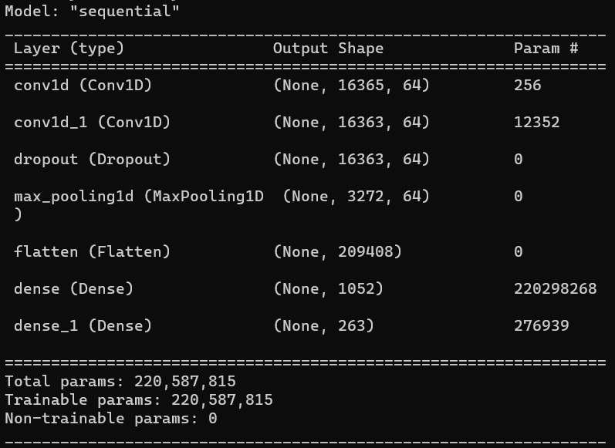
After training the CNN model, we assessed its performance by comparing predictions to real data using the confusion matrix. There are four values in the confusion matrix. True Positive (TP) is a measure of how well projections of positive outcomes compare to actual positive cases. The value of inaccurately making positive forecasts is known as a false positive (FP). True Negative (TN) measures the value of accurate negative predictions made from actual negative cases. False Negative (FN) is the value assigned to inaccurately foretelling negative outcomes.

Accuracy: Accuracy measures how well the CNN model performs when making predictions. It is determined as the ratio of the accurate forecast to the total prediction. The formula from measures the accuracy.

Accuracy= 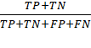
Precision: Precision is a measure of how well the CNN model can predict positive predictions overall, and how many of those positive predictions are right. A more accurate positive forecast results from greater precision.
Precision= 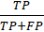
Recall: Similar to accuracy, recall counts the correctly optimistic predictions made from the right ones. Increasing recall value reduces the number of inaccurate predictions.
Recall=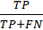
F1-Score: F1-Score requires recall and precision. It strikes a balance between the two metrics. F1-Score is helpful when the model outputs high FP and FN.

F1-Score= 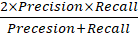

Experiment Result
We have randomly chosen 2 samples from the given datasets and found the results into (Figure 7&8). We found the accuracy is around 30-40%.
Sample 1: First input sample can be found into GitHub repository at
`\static\files\sample_input_001.xlsx`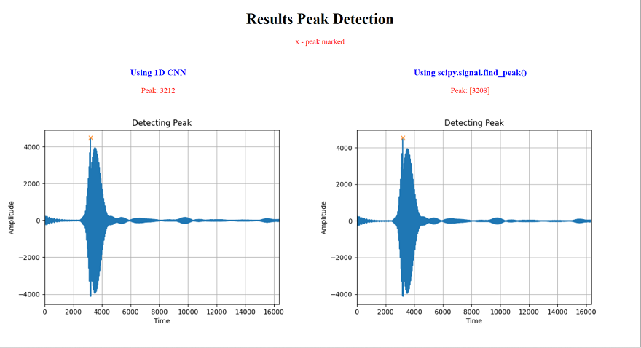

Figure 7: Result from the sample

Sample 2: Second input sample can be found into GitHub repository at
`\static\files\sample_input_002.xlsx`
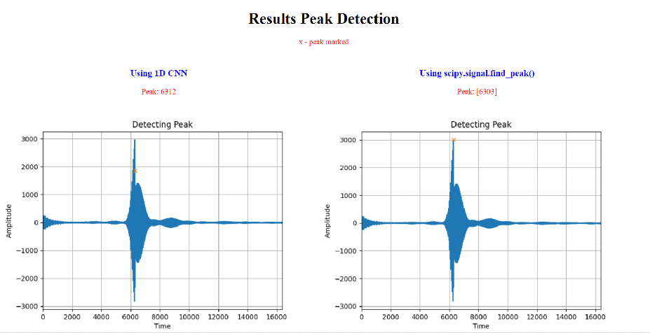
Figure 8: Result from the sample

Encountered problems
Although the evaluation of training experiment shows the promising result, as we conduct the experiment for 100 times, we found the low evaluation result in 1 of 100 times. The cause is still unknown, but we make an assumption that more information on signal is required to process noise free signal. We have faced another issue that dataset was changed in dimensions at last stage of project.

Discussion and conclution
The proposed neural network based peak detector exploits peak shape information successfully with a superior performance in all evaluated signals. Furthermore, it is shown that after grouping need approximation to match actual results that doesn't give high actual peak. But a window in which peak is present. To improve accuracy need to make small window which matches kernel size of CNN. Current window size is 62 which cannot be comment as good or bad since the sampling rate is unknown.

References

- Hoshen, Y., Weiss, R. J., & Wilson, K. W. (2015). Speech acoustic modeling from raw multichannel waveforms. In IEEE International Conference on Acoustics, Speech and Signal Processing (ICASSP) (pp. 4624–4628)
- LeCun, Y.; Bengio, Y.; Hinton, G. Deep learning. Nature 2015, 521, 436–444
- Zhu, Z., Enge, J. H., & Hannun, A. (2016). Learning multiscale features directly from waveforms. Proceedings of the Annual Conference of the International Speech Com-
munication Association (INTERSPEECH), (pp. 1305–1309).
- Bruce, A., Donoho, D., & Gao, H. Y. (1996). Wavelet analysis [for signal processing]. IEEE spectrum, 33(10), 26-35.
- Osgood, B. G. (2019). Lectures on the Fourier transform and its applications (Vol. 33). American Mathematical Soc.
- Aditi Singh, Survey Paper on Hilbert Transform with Its Applications in Signal Processing, (IJCSIT) International Journal of Computer Science and Information Technologies, Vol. 5 (3), 2014, 3880-3882.
- King, F. W. (2009b). Hilbert Transforms, Vol. 2, Cambridge University Press, Cambridge, UK.

